Instead of needing a whole separate window open for a terminal, Visual Studio Code has the ability to open a terminal within the workspace but not in a place that obstructs anything. There are two ways to go about opening the terminal within Visual Studio Code: a hotkey on your keyboard, or simply click a button. We will start with clicking a button. Open Visual Studio Code by double clicking it on your desktop or click on the search bar on the bottom left of your scree and typing “visual studio code” and pressing “Enter”. Next, you will look at the top of the window for where it says “Terminal”. Click that button, then click “New Terminal” (see image below), and voila!

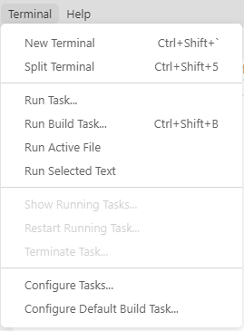

You now have a terminal on the bottom of the screen (see image below) which will work out of whatever folder you have open.

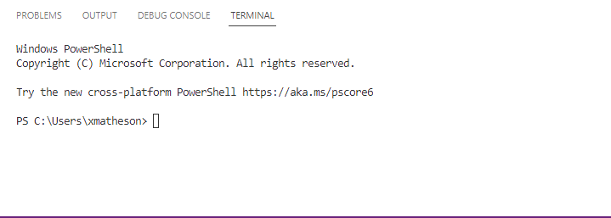

Now, for the keyboard shortcut. Follow the previous steps to get Visual Studio Code open, then on your keyboard, press down “Ctrl”, “Shift”, and “ ` ” all at the same time. You should see the same terminal appear at the bottom of the screen.

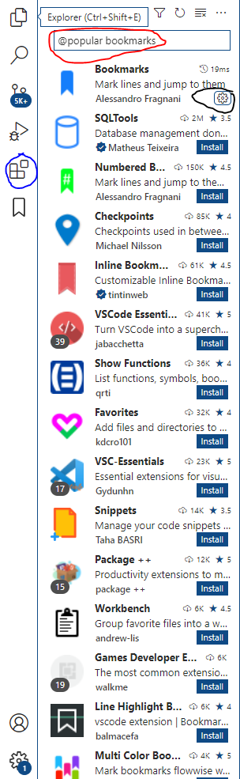Another nice thing that Visual Studio Code has comes from one of the extensions. This would be the extension “Bookmarks” by Alessandro Fragnani. This extension adds a way for you to move from one place in your code to another without needing to hunt it down. This is especially useful when you have very long code. The first thing you need to do is open Visual Studio Code, which we cover in the previous tutorial.

What you want to do next is to click the symbol on the left (circled in blue in image).

The next step would be to type “@popular bookmarks” in the search bar (area circled in red).

Finally, find the one with the blue bookmark symbol (or whichever bookmark related one you want, but this tutorial is for this one specifically) and click on the “Install” button (will be in the area circled in black). It should pop up with a confirmation page, close out of it and into a file with a decent amount of code.

Here, you want to right click on a line of code, go down to where it says “Bookmarks”, hover over it then click on “toggle”. You can also do this by pressing “Ctrl”, “Alt” and “K” at the same time. This will place a bookmark symbol on the left-hand side of the line number. Next, scroll away from your bookmark as much as possible. Now you want to right click, go down to “Bookmarks”, then click “Jump to Next” or “Jump to Previous”. You can also do this by pressing “Ctrl”, “Alt”, and “J” to go to previous and “Ctrl”, “Alt”, and “L” to go to next. These will all bring you to the bookmark you set without you needing to find it manually.

If you add more bookmarks around your code, pressing “Previous” will bring you to the closest bookmark above where you have your cursor, and “Next” will bring you to the closest bookmark below where you have your cursor.

One final thing that is nice in Visual Studio Code would be the various keyboard shortcuts which are different between Atom and Visual Studio Code. For example, to select multiple lines in different points of the line, you hold “Alt” then click where you would like to select. You can also use this to select multiple places in the same line. These two shortcuts would be very useful if you need to write the same thing in several different places or delete something in several different places. Another shortcut that I just found out as of writing this, holding “Shift”, “Alt”, and either the up-arrow key or down arrow key will copy the line you have selected in the direction you pressed. This would be useful in a situation where two lines will have almost identical code but with some small changes. Holding “Shift” then pressing either the up-arrow or down arrow will select everything between where your selection was to where it ended up.